InGARSS 2024
2024 IEEE India Geoscience and Remote Sensing Symposium, NIO, Goa
Hosted by IEEE GRSS Bombay Section

- Home (Front/First Webpage content)
Welcome to InGARSS 2024
Welcome to InGARSS 2024, the premier conference for advancing the field of geoscience and remote sensing! This year, we gather to exchange cutting-edge research, innovative technologies, and transformative ideas that push the boundaries of Earth observation. Join us as we explore new frontiers, collaborate with experts from around the globe, and chart a course towards a more sustainable and resilient future.
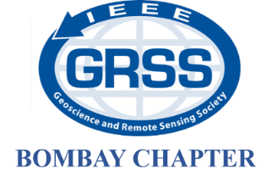
Host Chapter

Local Host Institute
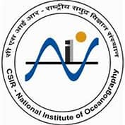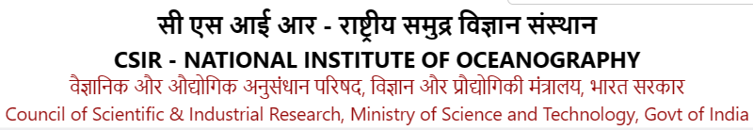

Collaborating Chapters

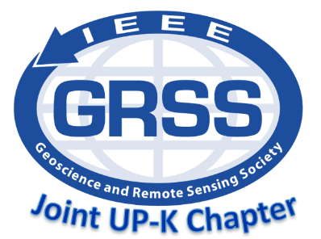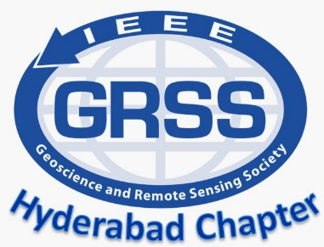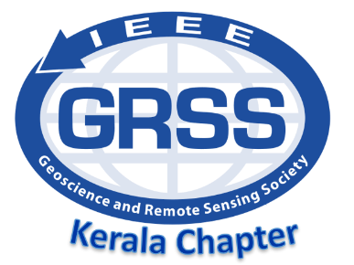

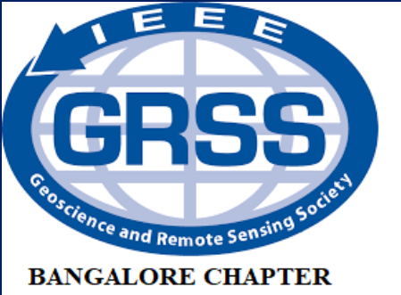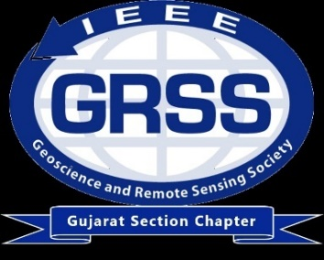
GRSS Delhi Chapter

Tentative Financial Co-sponsorship


News and Updates: InGARSS 2024 will be organized during first week of December 2024 and registration forms will be out soon.

- GENERAL (Third Webpage Content)
  - Organizing Committee
Positions | Volunteer
Honorary Chairs | Dr. Shiv Mohan, India GRSS Liaison  Dr. Prakash Chauhan, Director, NRSC  Dr. Sunil Kumar Singh, Director, NIO Goa
General Chairs | Prof. Dharmendra Singh, IIT Roorkee, Roorkee  Prof. Gulab Singh, IIT Bombay, Mumbai
Organizing Chairs | Prof. Mousmi Chaurasia, MJCET Hyderabad  Prof. Varsha Turkar, VIT Mumbai
Technical Program Committee Chairs | Dr. Atul Varma, SAC Ahmedabad  Prof. Rama Rao Nidamanuri, IIST Trivandrum  Dr. Triloki Pant, IIIT Prayagraj
Publication Chairs | Dr. K. C. Tiwari, DTU Delhi  Dr. V. S. Rathore, BIT Mesra, Ranchi  Dr. Ajay Maurya, IIT Roorkee, Roorkee
Exhibition Chairs | Lt. Col. Gaganpreet Singh, Delhi  Hari Sankar, IIRS Dehradun
Industry and Sponsorship Chairs | Dr. Vijender Busi Reddy, ADRIN  Lt. Col. Gaganpreet Singh
Local Hospitality Chairs | Mr. Yeshudas Muttu, DBCE Goa  Ms. Mohini Naik, DBCE Goa
Publicity and Website Chairs | Prof. Abhilasha Mishra, MIT Chh. Sambhajinagar  Prof. Shyam Lal, Chair (Elect-2024), GRSS Bangalore Chapter
WIE Chairs | Dr. Mugdha Apte, APSIT  Dr. Alka Singh, AV Vidyapeetham
Finance Chair | Dr. Priyanka, SNU Ranchi/IIT Roorkee
YP Event Chairs | Prof. Surendar M., VIT, Vellore  Dr. Bala Raju Nela, IIT Bombay
Invited Session Chairs | Prof. Deepak Mishra, Chair, GRSS Kerala Chapter  Prof. Vijay Kumar, VIT, Vellore
Tutorial Chairs | Dr. Anup Kumar Das, SAC Ahmedabad  Dr. Smita Nirkhi, GHRIET Nagpur
Logistics Chairs | Akhil Masurkar, VIT Mumbai  Dr. Rishikesh Kulkarni, SIT Pune
Social Media Chairs | Prof. Praveen Wankhede, SSGMCE  Prof. Baleasaheb Agarkar, SCOE

  - Technical Program Committee
Dr. Paul Rosen (JPL, USA)
Dr. Raj Kumar (SAC, ISRO)
Prof. Werner Wiesbeck (Karlsruher Institut für Technologie)
Prof. Albert Morera (DLR)
Prof. K. P. Singh (Former Director IIT-BHU)
Prof. P. C. Pandey (Former Director NCPOR)
Prof. Yoshio Yamaguchi (Niigata University)
Prof. H. Kobayashi (Osaka IT)
Dr. Deepak Mishra (UGA)
Dr. Venkataraman Lakshmi (University of Virginia, USA)
Dr. Jasmeet Judge (University of Florida, USA)
Dr. Yahia Hussein (INRIA France)
Dr. Margaret Simoes (Brazil)
Dr. Anjali Awasthi (Cornoll Univ. Canada)
Prof. Jian Yang (Tshingua Univ., China)
Prof. Wu Fung (CAS, China)
Prof. Manoj Arora (VC, SRM)
Dr. Abhilash Chandel (Washington State University)
Prof. Jaya Nair (IIIT, Bangalore)
Prof. B.S. Dayasagar (Director, ISI, Bangalore)
Prof. Ashish Ghosh (ISI, West Bengal)
Prof. Animesh Maitra (University of Calcutta)
Prof. T. N. Singh (Director, IIT Patna)
Prof. P. K. Jain (Director NIT Patna)
Dr. A. K. Singh (Former Director, DLRL (DRDO), Hyderabad)
Dr. R. P Singh (Director, IIRS)
Dr. Dinesh Kumar Singh (SAC)
Prof. S. Pal (Former VC DAIT, Pune)
Dr. Anil Kulkarni (IISc)
Dr. Snehmani (DRDO)
Dr. I. M. Bahuguna (Former DD, SAC)
Dr. Sandeep Oza (SAC)
Prof. O.P.N. Calla (Director, ICRS)
Prof. Madukar Chandra (Chemintz Univ., Germany)

  - Contact (iitbgrssstuchap@gmail.com)
    - What is InGARSS?
      - InGARSS stands for the Indian Geoscience and Remote Sensing Symposium. It is an annual conference organized by the IEEE Geoscience and Remote Sensing Society (GRSS) dedicated to showcasing the latest advancements in remote sensing technologies and applications.

    - Who can attend InGARSS 2024?
      - InGARSS 2024 is open to researchers, scientists, engineers, students, industry professionals, policymakers, and anyone interested in the field of geoscience and remote sensing.

    - When and where does InGARSS 2024 take place?
The location and dates of InGARSS 2024 is NIO, Goa from 2-5 Dec 2024.

    - What topics are covered at InGARSS 2024?
      - InGARSS 2024 covers a wide range of topics related to geoscience and remote sensing, including but not limited to satellite imaging, data processing techniques, environmental monitoring, climate change, disaster management, agriculture, forestry, urban planning, and oceanography.

    - How can I submit a paper or presentation to InGARSS 2024?
      - Information on paper submission guidelines, deadlines, and presentation formats can be found on the official InGARSS 2024 website. Authors are typically required to submit abstracts or full papers through an online submission system.

- PROGRAM (Fourth Webpage Content)

  - Accepted Paper list

- For Authors (Fifth Webpage Content)
  - Important Dates

  - Presentation Guidelines

  - Author Guidelines

- Paper size, margins, and fonts: Specify the required paper size (e.g., A4), margins (e.g., 1 inch), and font type and size (e.g., Times New Roman, 12-point).
- Title: Provide guidelines for formatting the title of the paper, including capitalization, font size, and style.
- Author information: Specify the format for listing authors' names, affiliations, and contact details. Include guidelines for indicating corresponding author(s).
- Abstract: Provide instructions for formatting the abstract, including word limit, structure, and content requirements.
- Main text: Outline guidelines for organizing the main body of the paper, including sections such as Introduction, Methods, Results, Discussion, and Conclusion. Specify any subheading formatting requirements.
- References: Provide guidelines for formatting citations and references according to a specific citation style (e.g., APA, IEEE).

- Submission platform: Provide information on the online submission platform or system used for submitting conference papers.
- Originality: Emphasize the importance of originality and avoiding plagiarism. Provide guidelines for citing sources and acknowledging contributions from other researchers.
- Language: Specify the language requirements for conference papers (e.g., English).
- Length: Provide guidelines for the maximum length of the paper, including word count or page limit.
- Figures and tables: Provide instructions for formatting figures, tables, and other visual elements. Include guidelines for captions, labels, and placement within the text.
- Acknowledgments: Specify guidelines for including acknowledgments for funding, support, or assistance received during the research process.

- Travel (6th Webpage Content)
  - Accommodation
  - Travel Support
  - VISA
  - Venue: NIO, Goa

- Registration (7th Webpage Content)

  - Registration Fees
Registrations at Various levels | Eary Bird registration  (18% GST included) | Regular  (18% GST included)
IEEE Students Members | ₹9,204 | ₹10,384
Student Non-Members | ₹11,328 | ₹12,508
GRSS Members | ₹14,160 | ₹16,048
IEEE Members | ₹16,992 | ₹18,408
Non-Members | ₹20,296 | ₹22,656
International GRSS Members | ₹29,736 | ₹32,568
International IEEE Members | ₹35,400 | ₹38,232
International Non-Members | ₹42,480 | ₹45,312
Tutorial/ registrations (Students/Professional) | ₹4,248 | ₹5,428

